What is History – Class Brainstorm

- History is about ancient cultures that are no longer with us
- Big and important events that happened long ago.
- The Big Bang
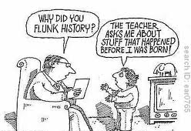
- Research about the Titanic
- Learning about the past
- What happened when our Ancestors were around
- Dinosaurs
- War - World War
- Remembrance
- Something that has happened many years ago

What is History – Class Brainstorm

- History is about ancient cultures that are no longer with us
- Big and important events that happened long ago.
- The Big Bang
- Research about the Titanic
- Learning about the past
- What happened when our Ancestors were around
- Dinosaurs
- War - World War
- Remembrance
- Something that has happened many years ago

